Kubernetes services:
What is service?
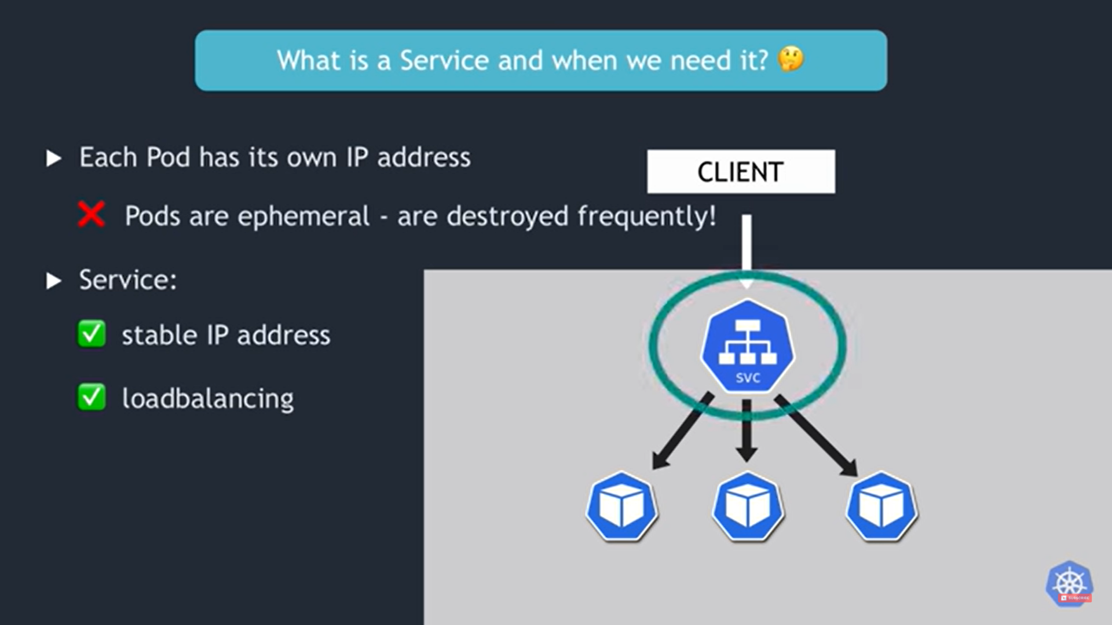

Service Types:
- ClusterIP
- NodePort
- Headless services
- LoadBalancer

ClusterIP: This is the default type. It exposes the Service on an internal cluster IP. It's used for communication between Pods within the cluster.
NodePort: This type exposes the Service on a static port on each Node's IP. It's useful for accessing the Service from outside the cluster, typically for development or testing purposes.
Headless services: A "headless service" is a special type of service in Kubernetes that is used when you don't need or want load balancing or a single virtual IP address for pods. Instead, it allows you to have direct DNS access to each pod that is part of the service.
LoadBalancer: This type provisions an external load balancer in a cloud environment (e.g., AWS ELB, GCP Load Balancer) to distribute traffic to the Service. It's used for exposing services to the public internet.

Cluster IP service

In Kubernetes, clusterIP is a field that you can specify when defining a Service resource. The clusterIP field determines the virtual IP address assigned to the Service within the cluster's internal network. This virtual IP address is reachable only from within the Kubernetes cluster and is used to provide internal load balancing to the Pods associated with the Service.

Here are the key aspects of clusterIP:

- Internal Network Load Balancing: The clusterIP value represents the IP address that other Pods within the same Kubernetes cluster can use to access the Service. When a Pod sends traffic to the clusterIP, Kubernetes performs internal network load balancing to distribute the traffic among the Pods associated with the Service.
- Default Behavior: If you don't specify a clusterIP explicitly when defining a Service, Kubernetes assigns it a virtual IP address from the cluster's internal IP address range.
- Static IP: You can specify a specific clusterIP if you need the Service to have a predictable, fixed IP address within the cluster. This can be useful in scenarios where other components rely on a consistent IP address for the Service.
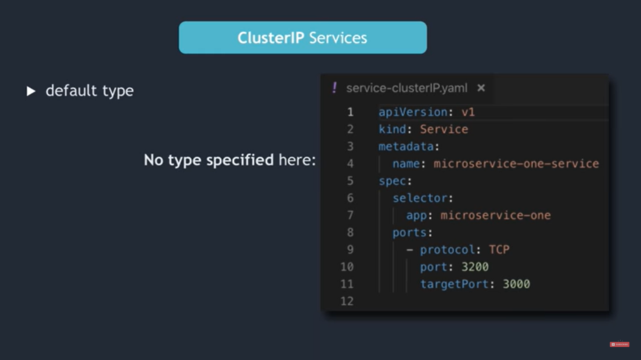
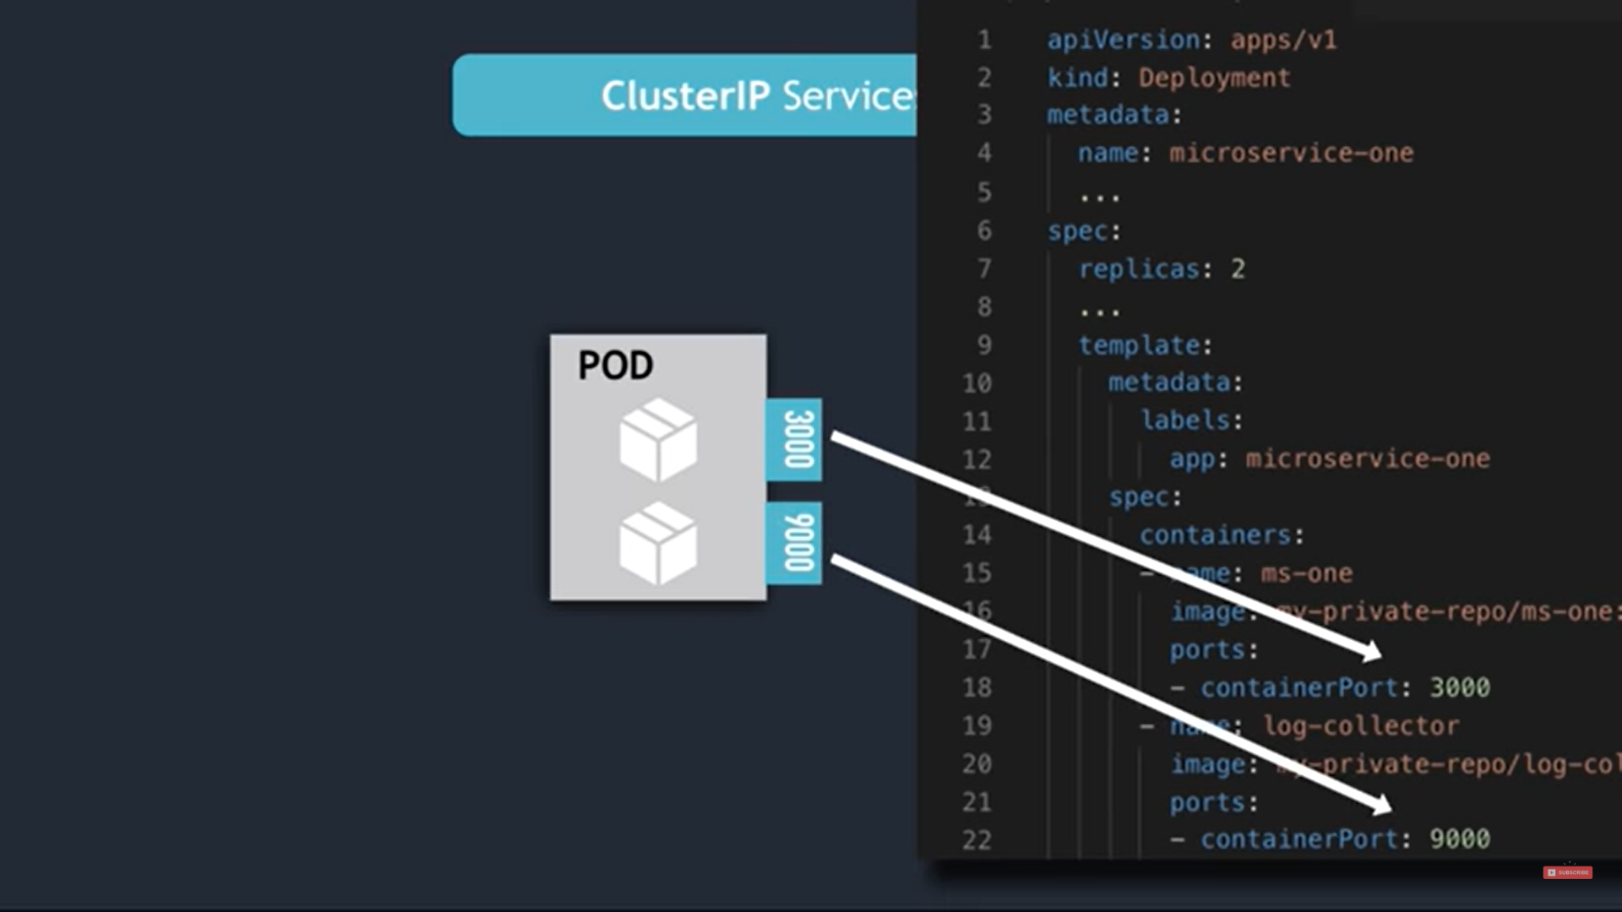

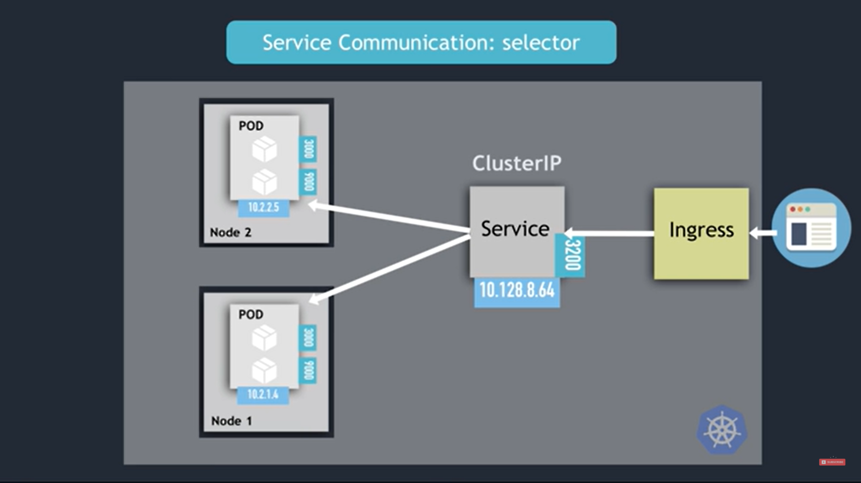
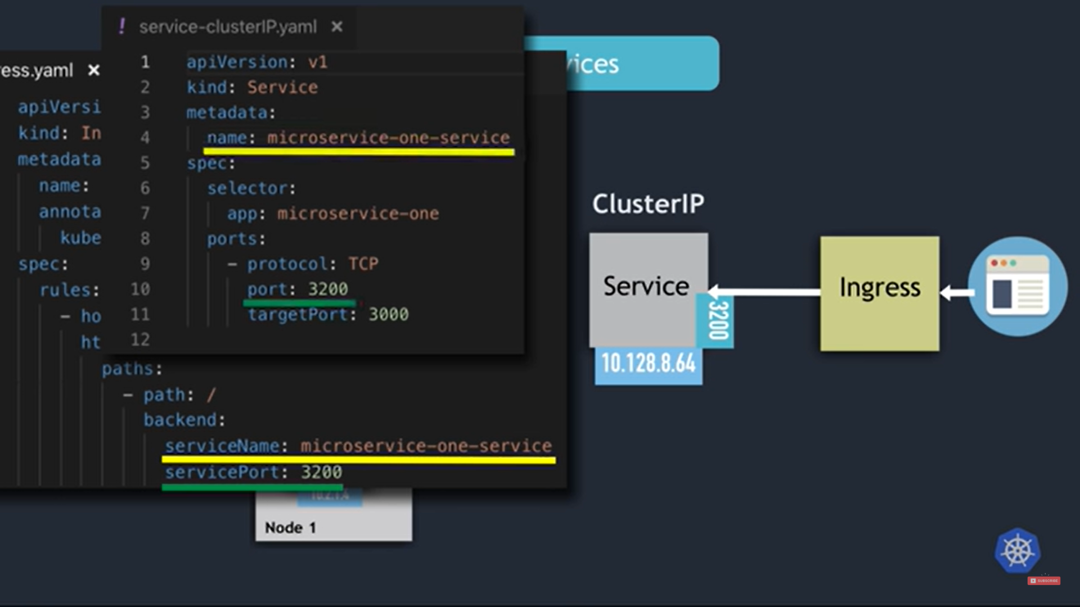

Use case:
- Database Connections: Services that connect to databases or other stateful services often use clusterIP to establish connections. For example, an application service may connect to a database service using the clusterIP as the database server's address.

How service can communicate with pods?
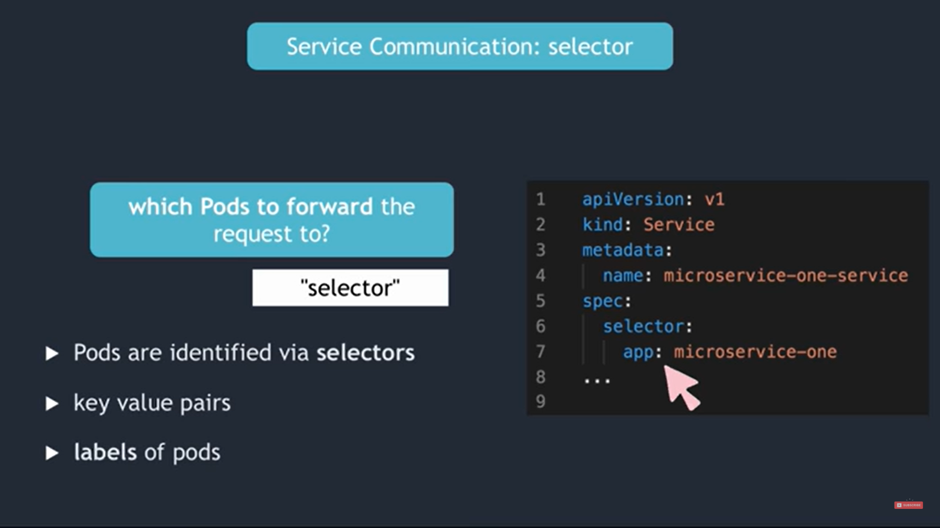
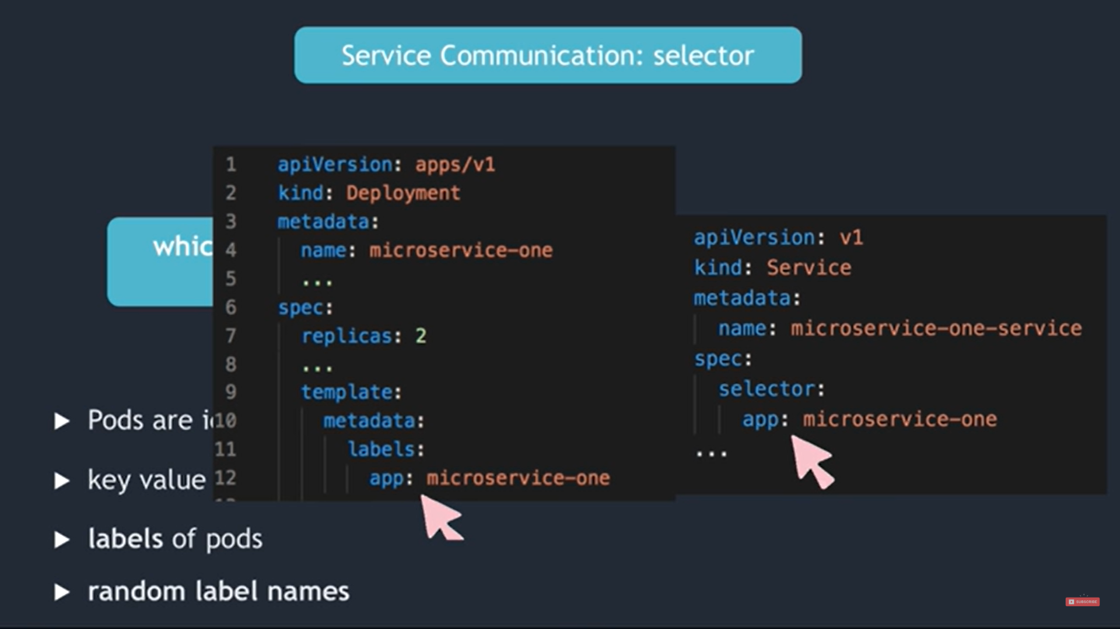
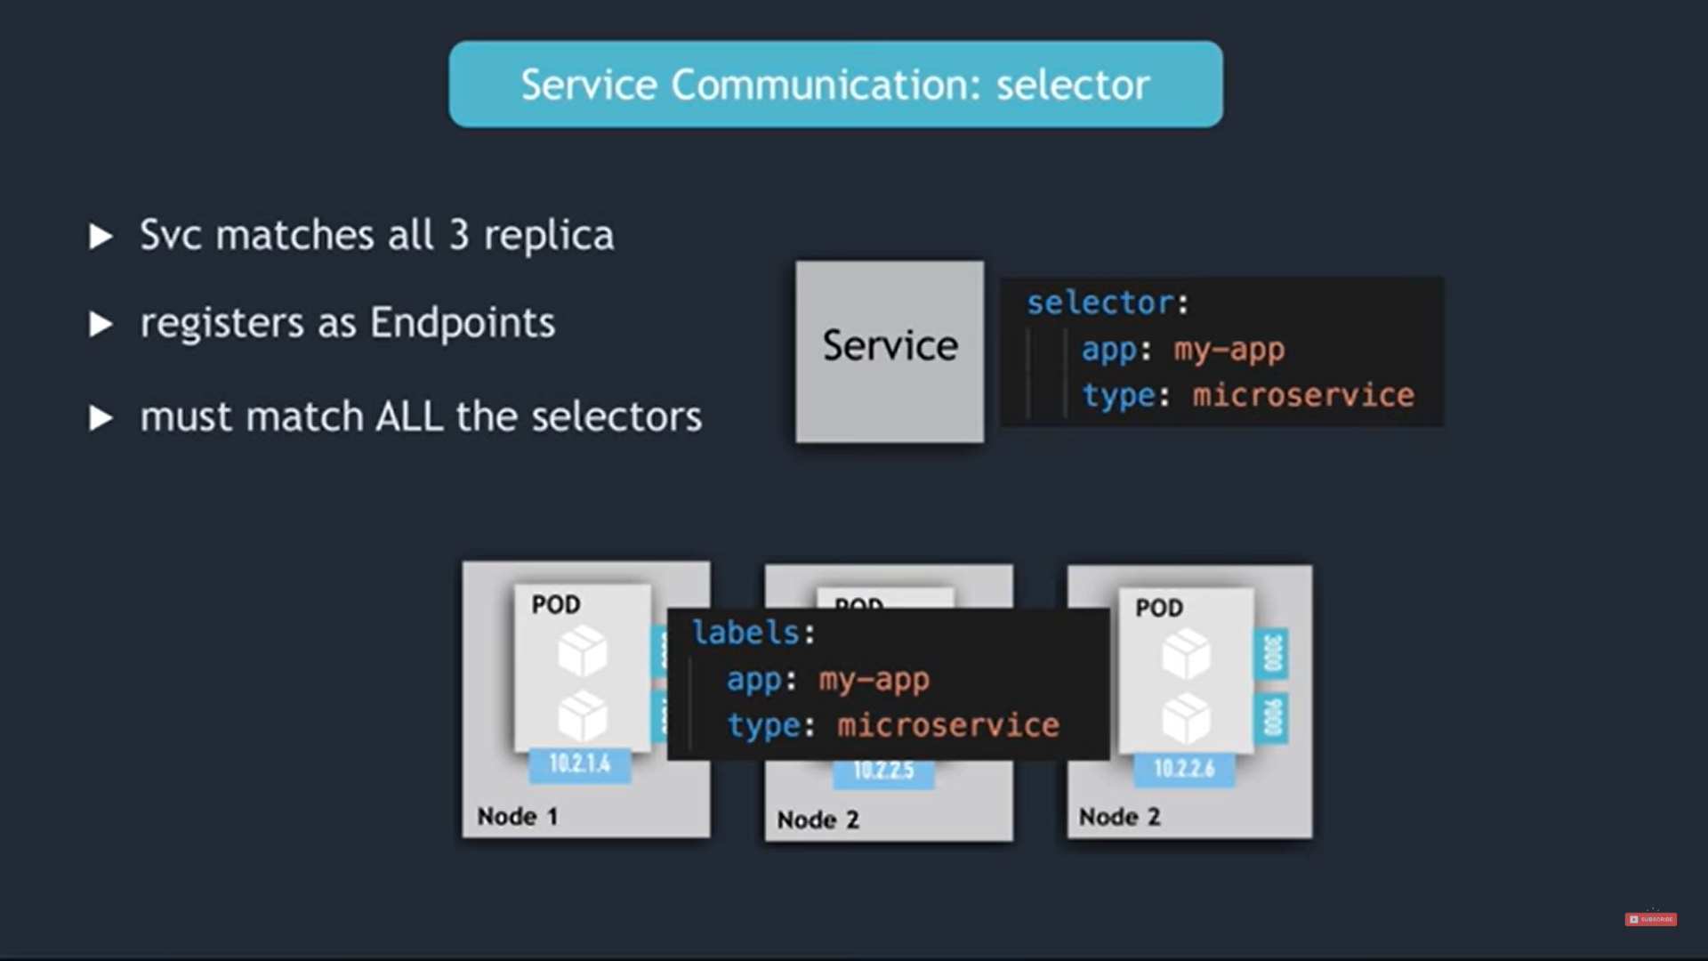

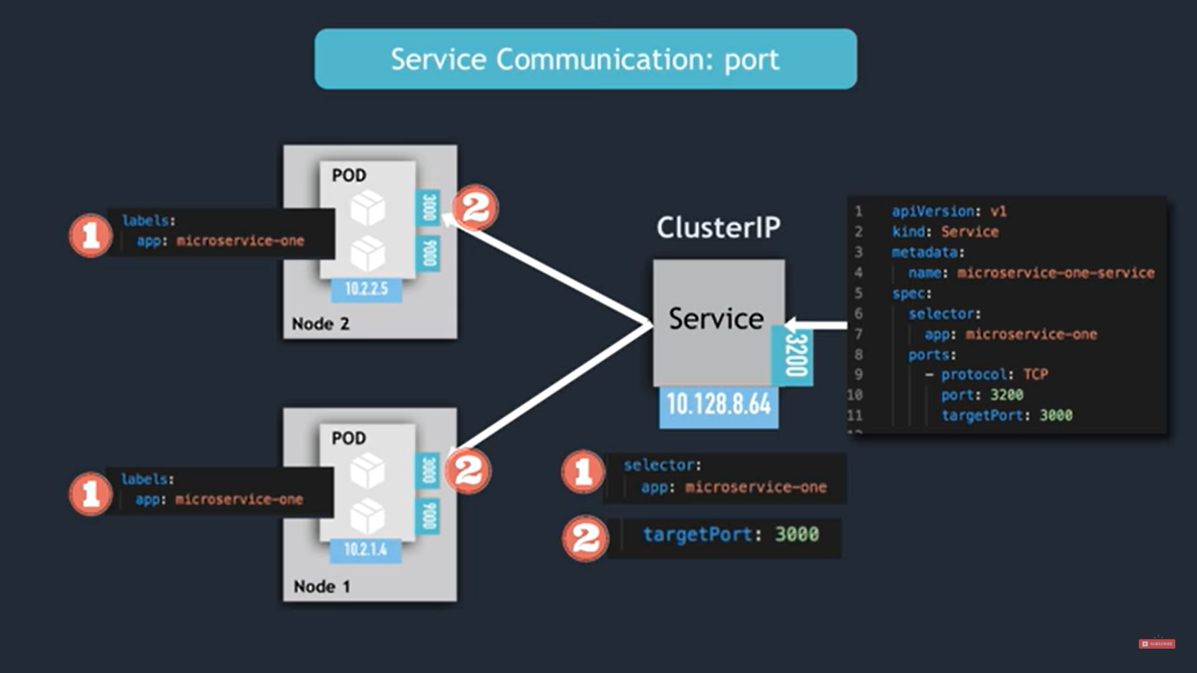

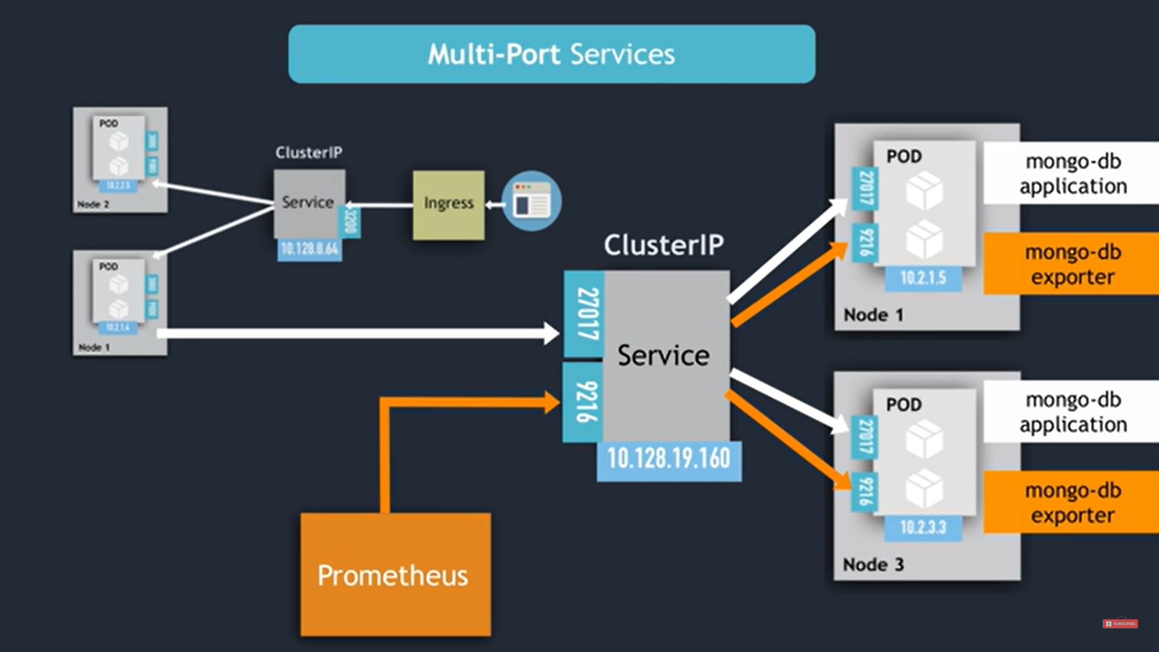
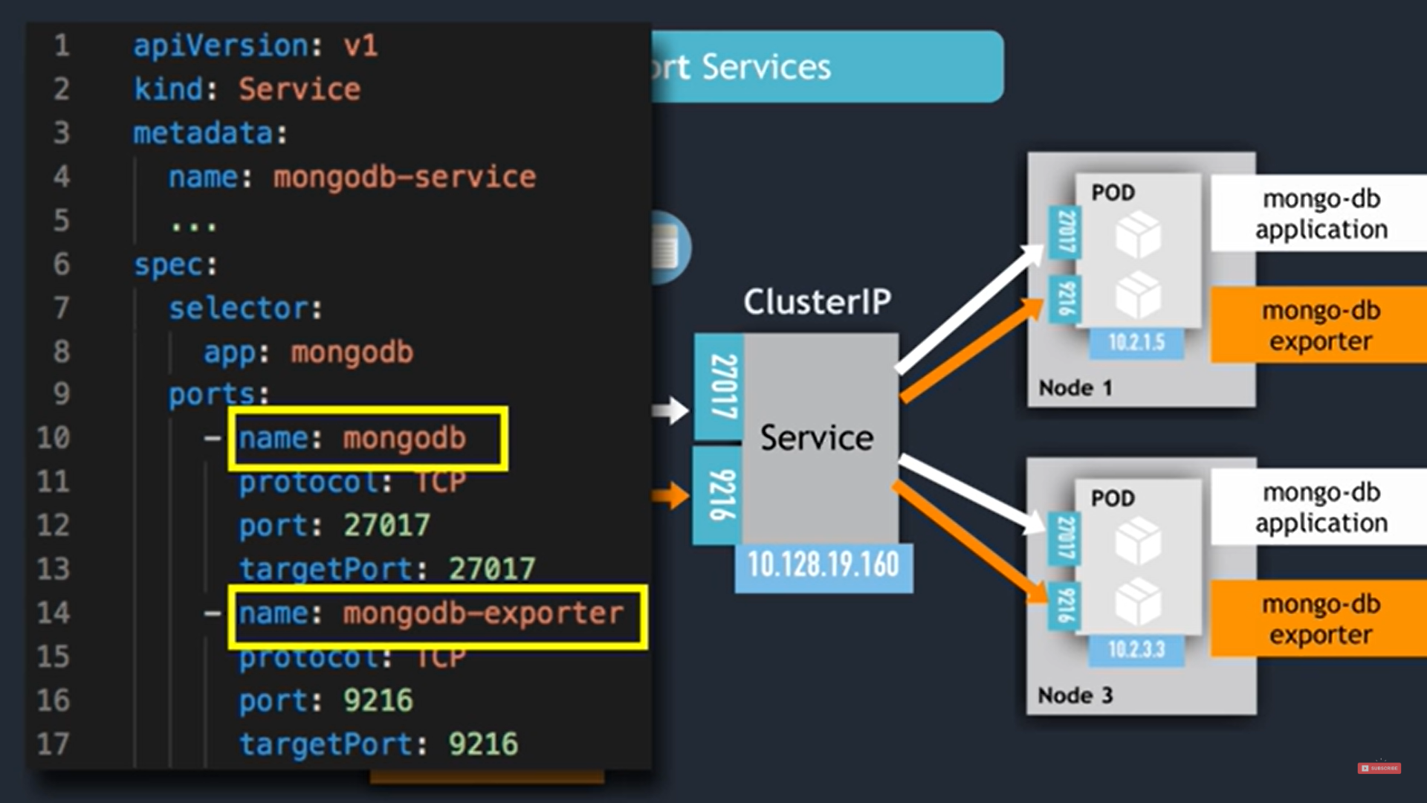

Headless services:

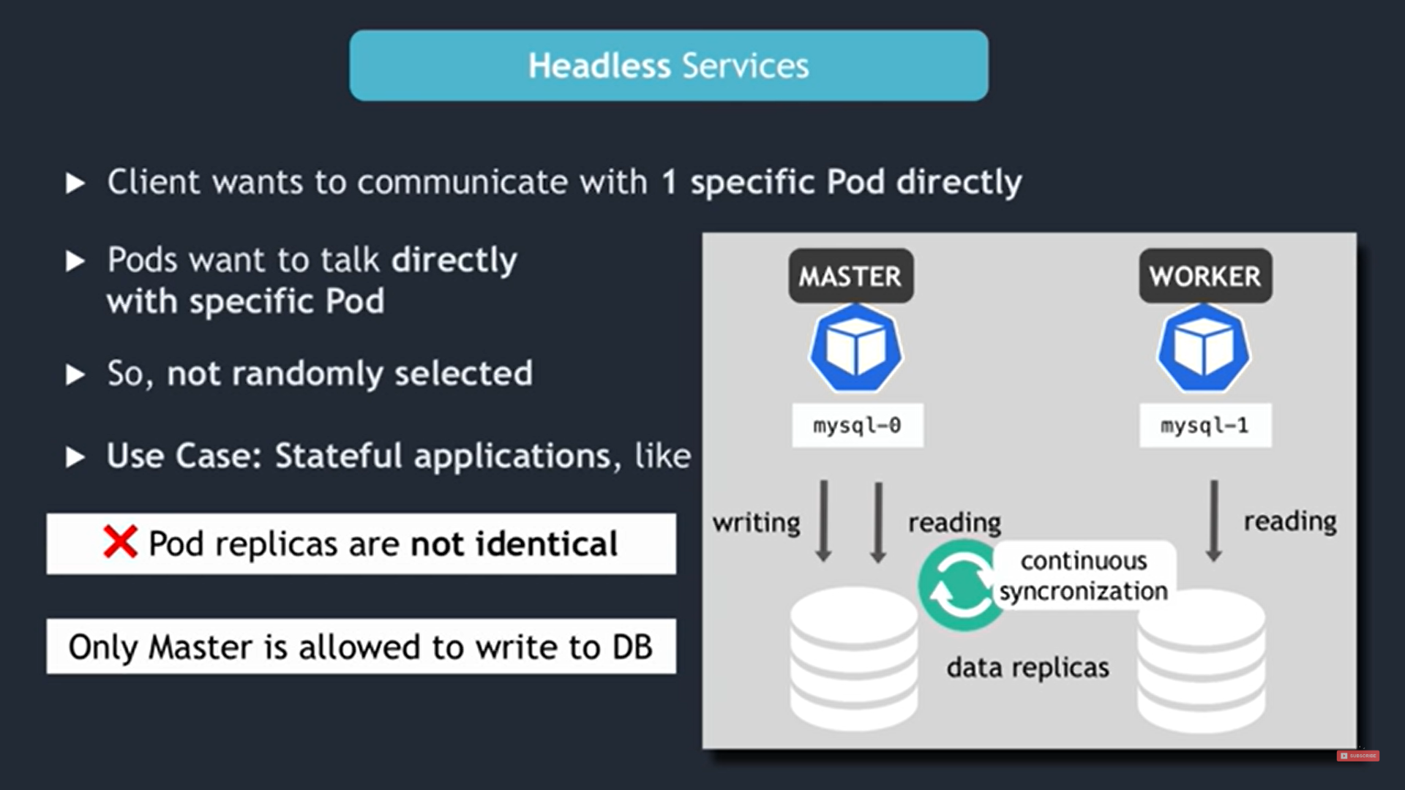
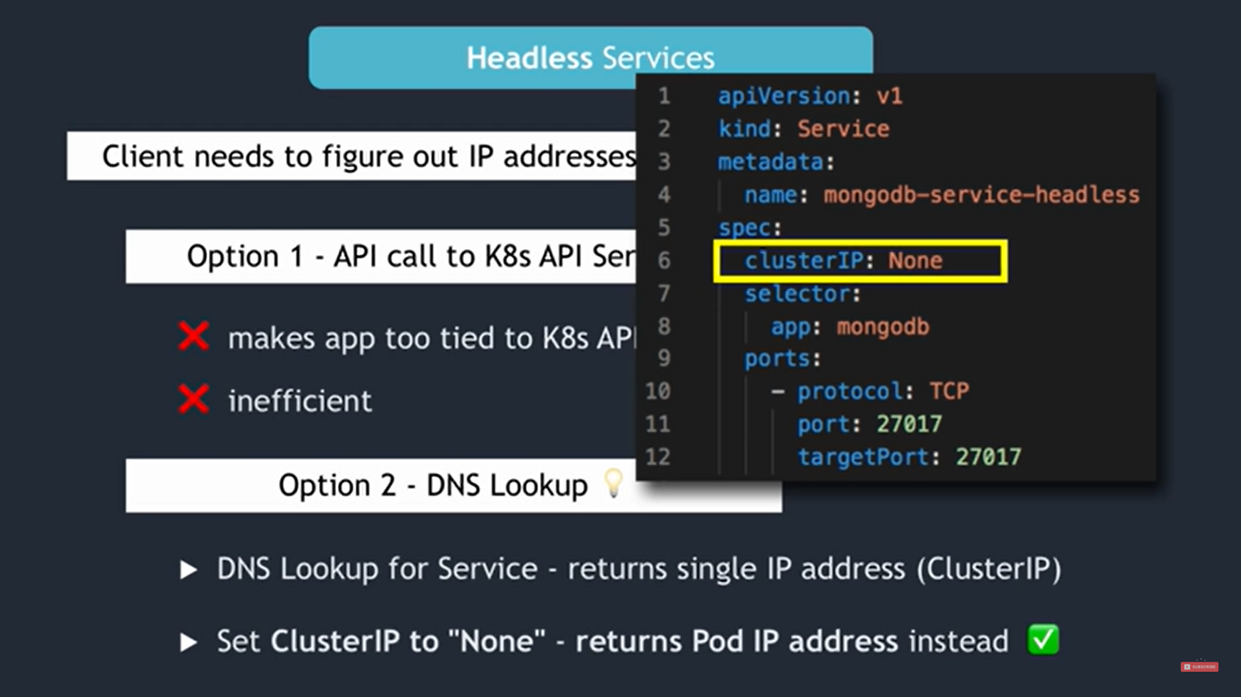
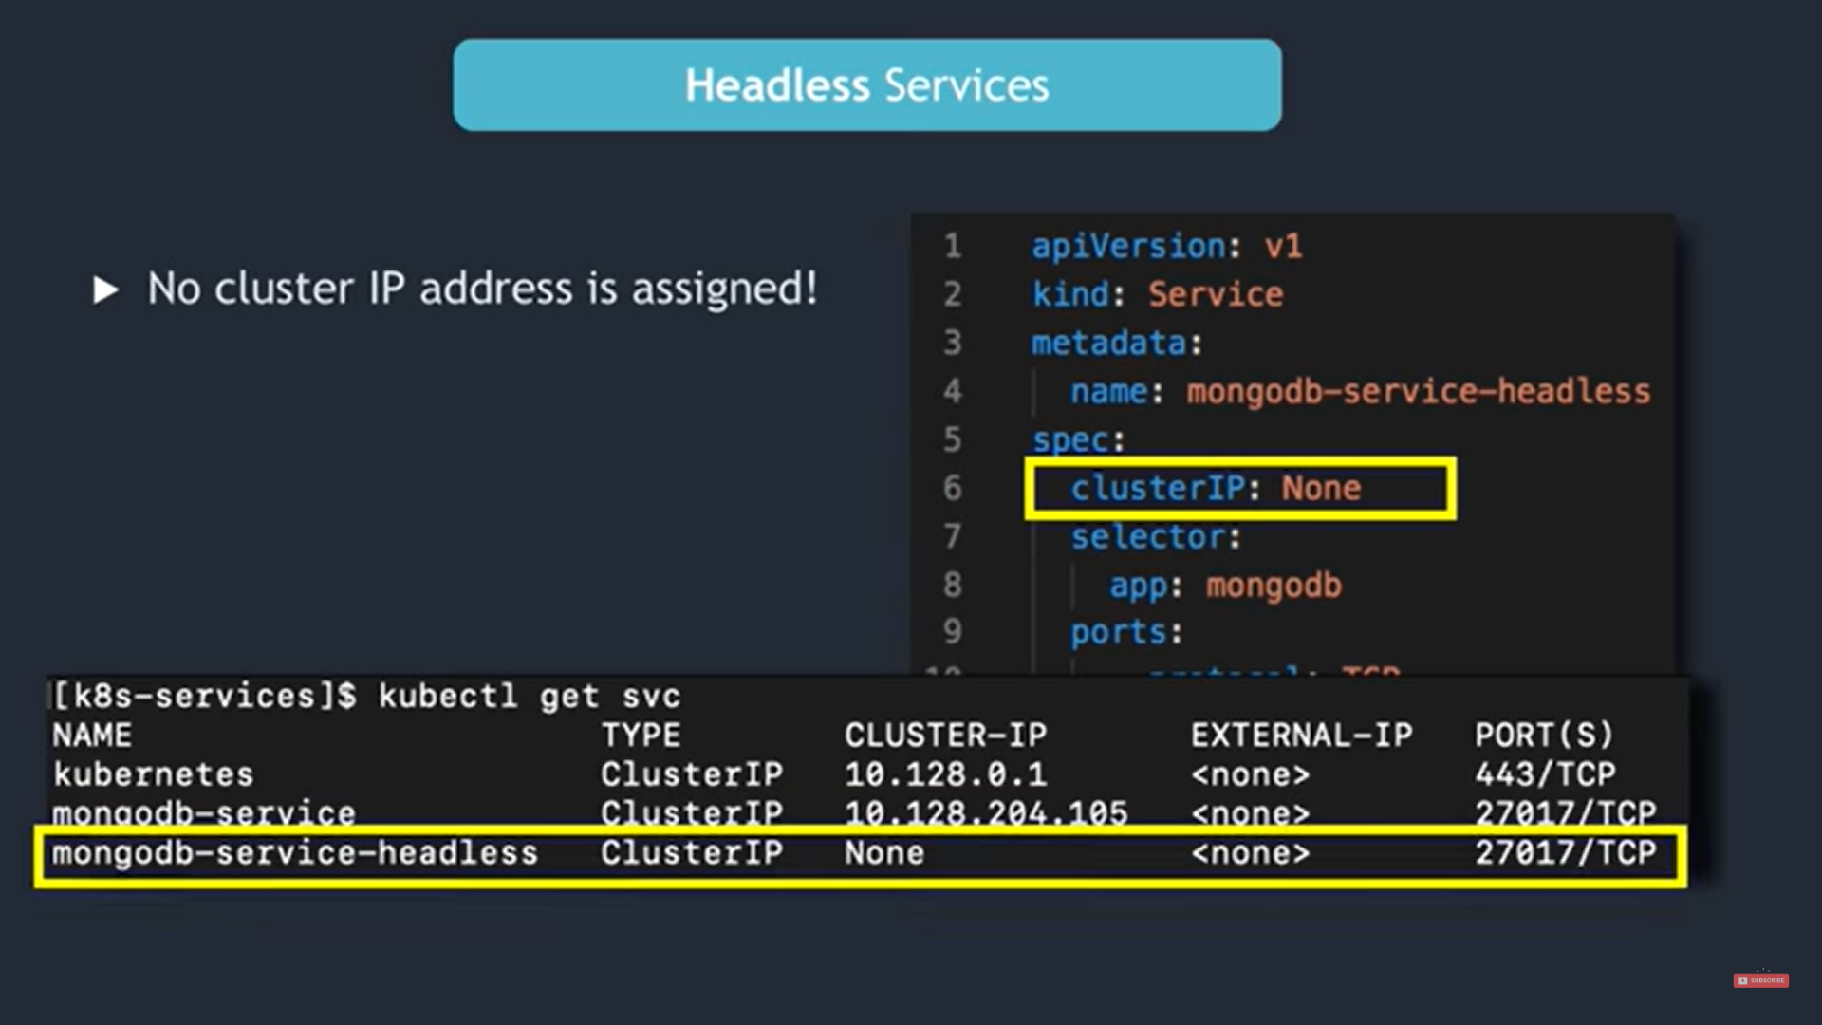

Key characteristics of a headless service:

- No Cluster IP: Headless services do not have a Cluster IP, so there's no single virtual IP address that represents the service.
- DNS Resolution: Each pod associated with the headless service gets its DNS record in the cluster's DNS. The DNS record is typically of the form <pod-name>.<service-name>.<namespace>.svc.cluster.local, and it resolves to the individual pod's IP address.

Use Cases:
- StatefulSets: Headless services are commonly used with StatefulSets to provide stable network identities to pods. Each pod can be accessed using DNS, which is essential for stateful applications.
- Custom DNS Routing: Headless services can also be used when you want to perform custom DNS routing or when you need to access pods individually rather than as a group.

NodePort
In Kubernetes, a NodePort is a type of Service that exposes an application running in a cluster to the outside world. It opens a specific port on all nodes (virtual machines) in a Kubernetes cluster and routes traffic that arrives on that port to the Service associated with it.
Use Cases: NodePort Services are often used during development and testing or in situations where you don't have access to an external load balancer. They can be a convenient way to expose web applications, APIs, or other services to the public or internal users.

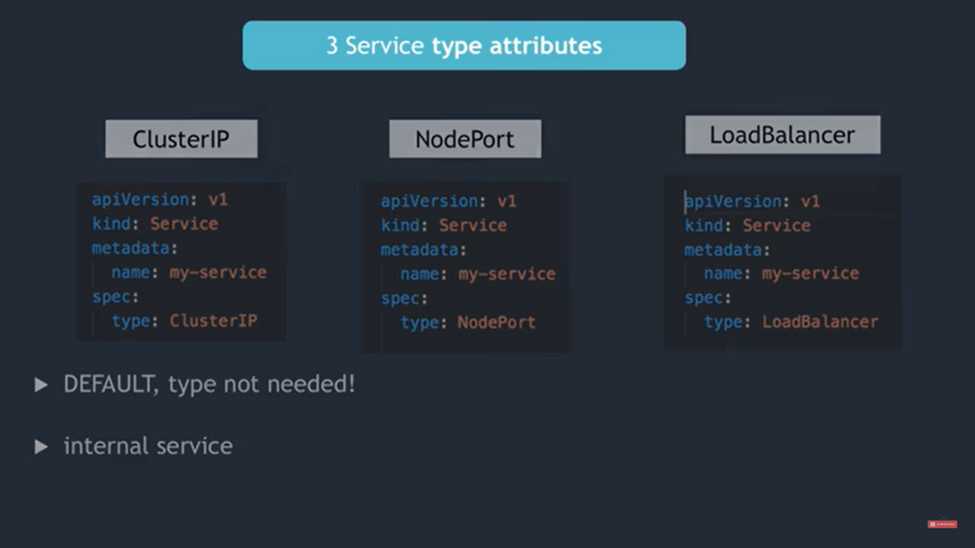

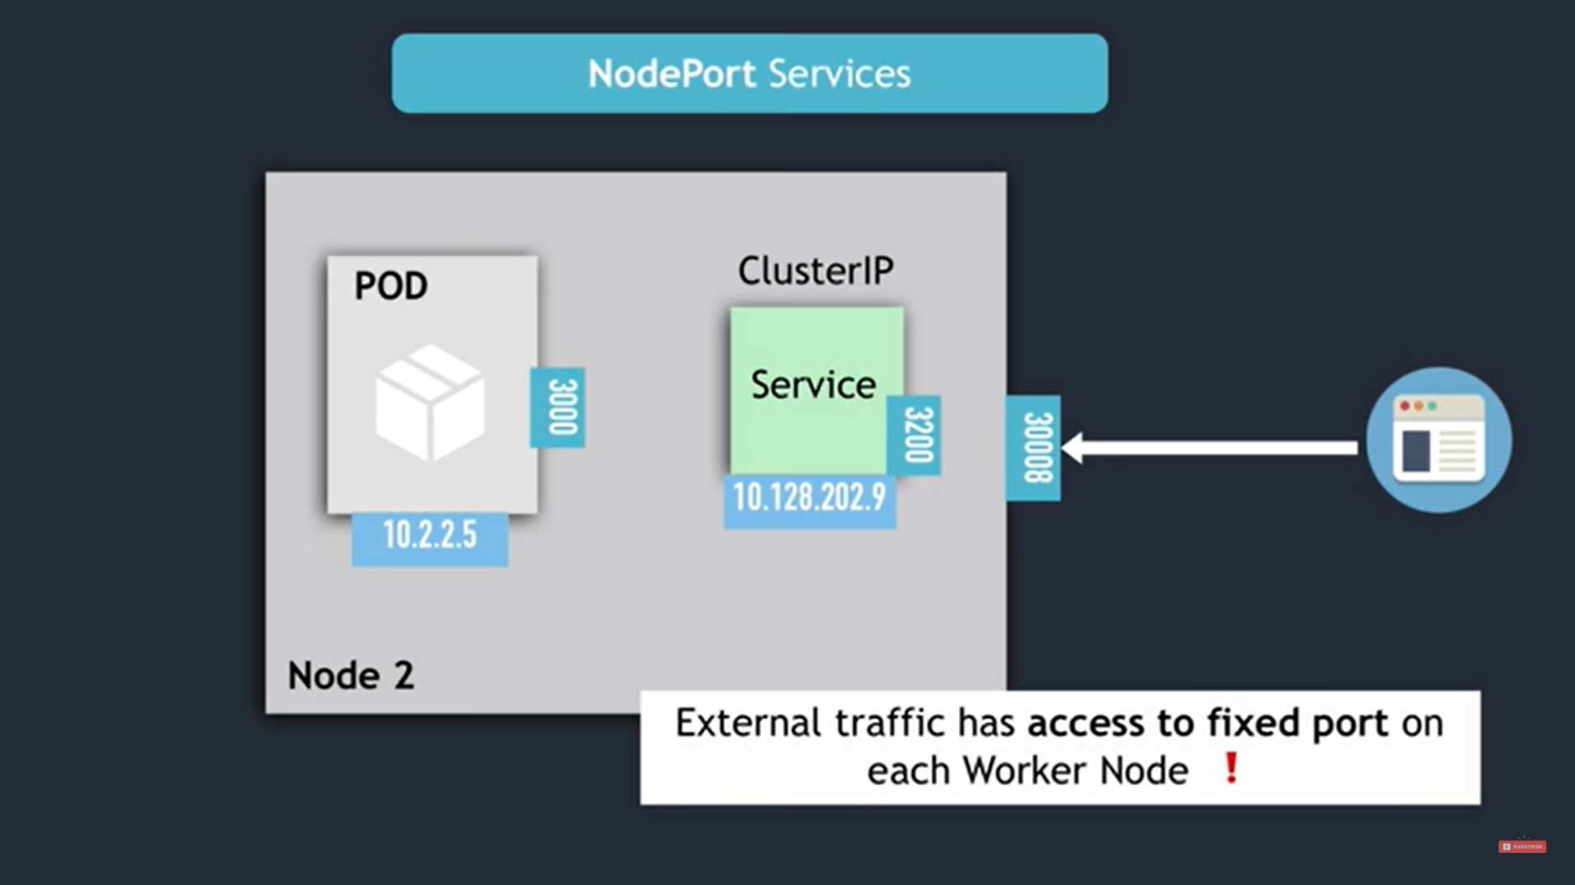
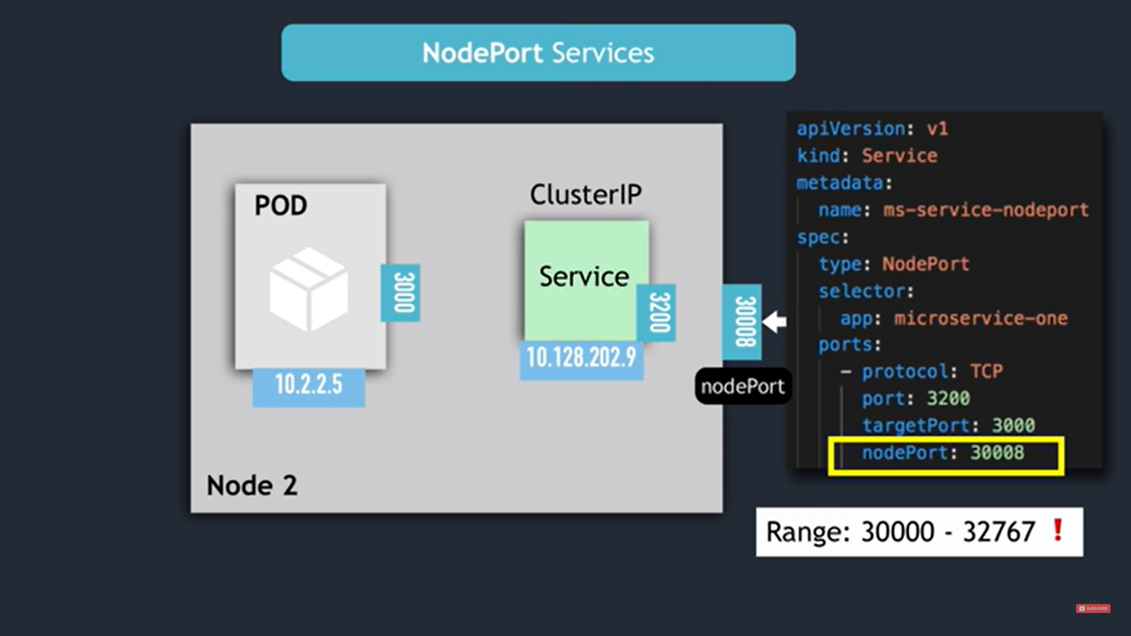
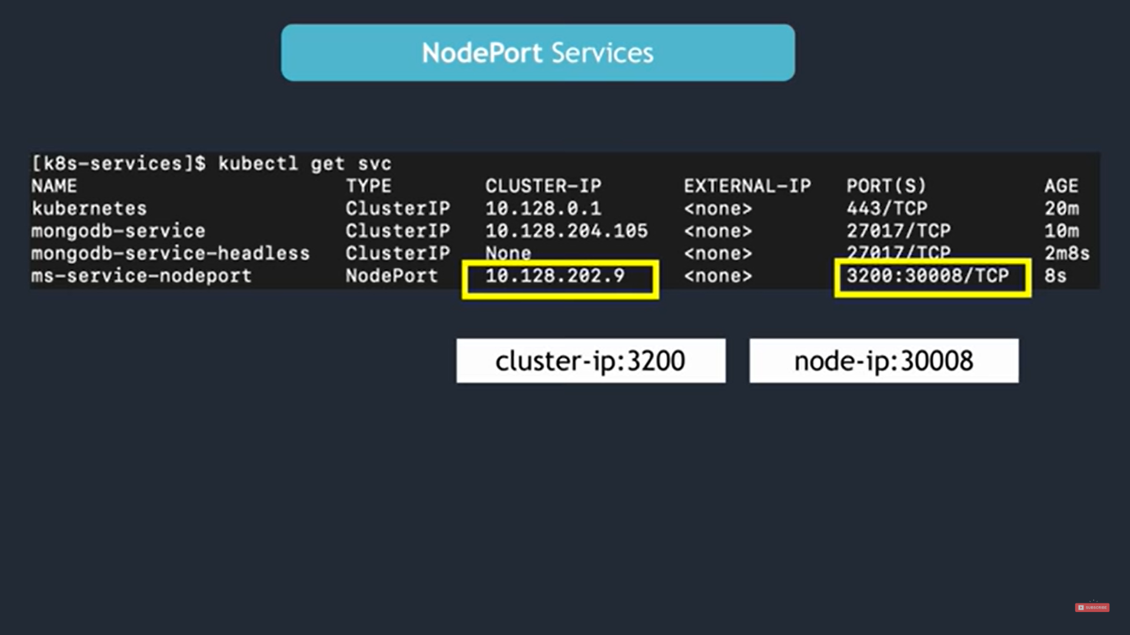
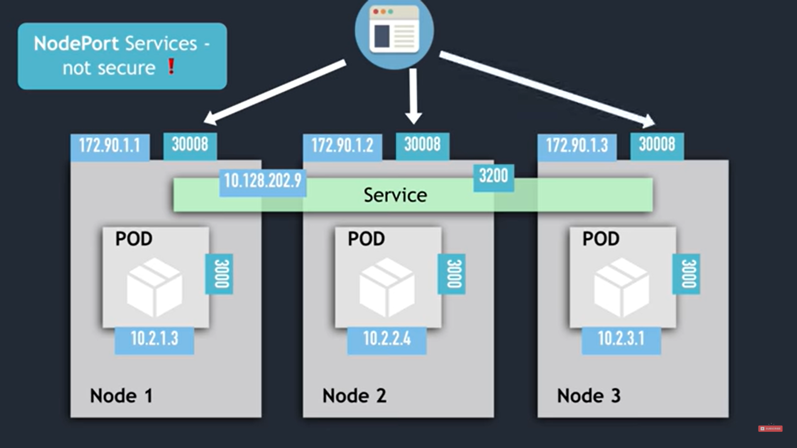

Load Balancer service
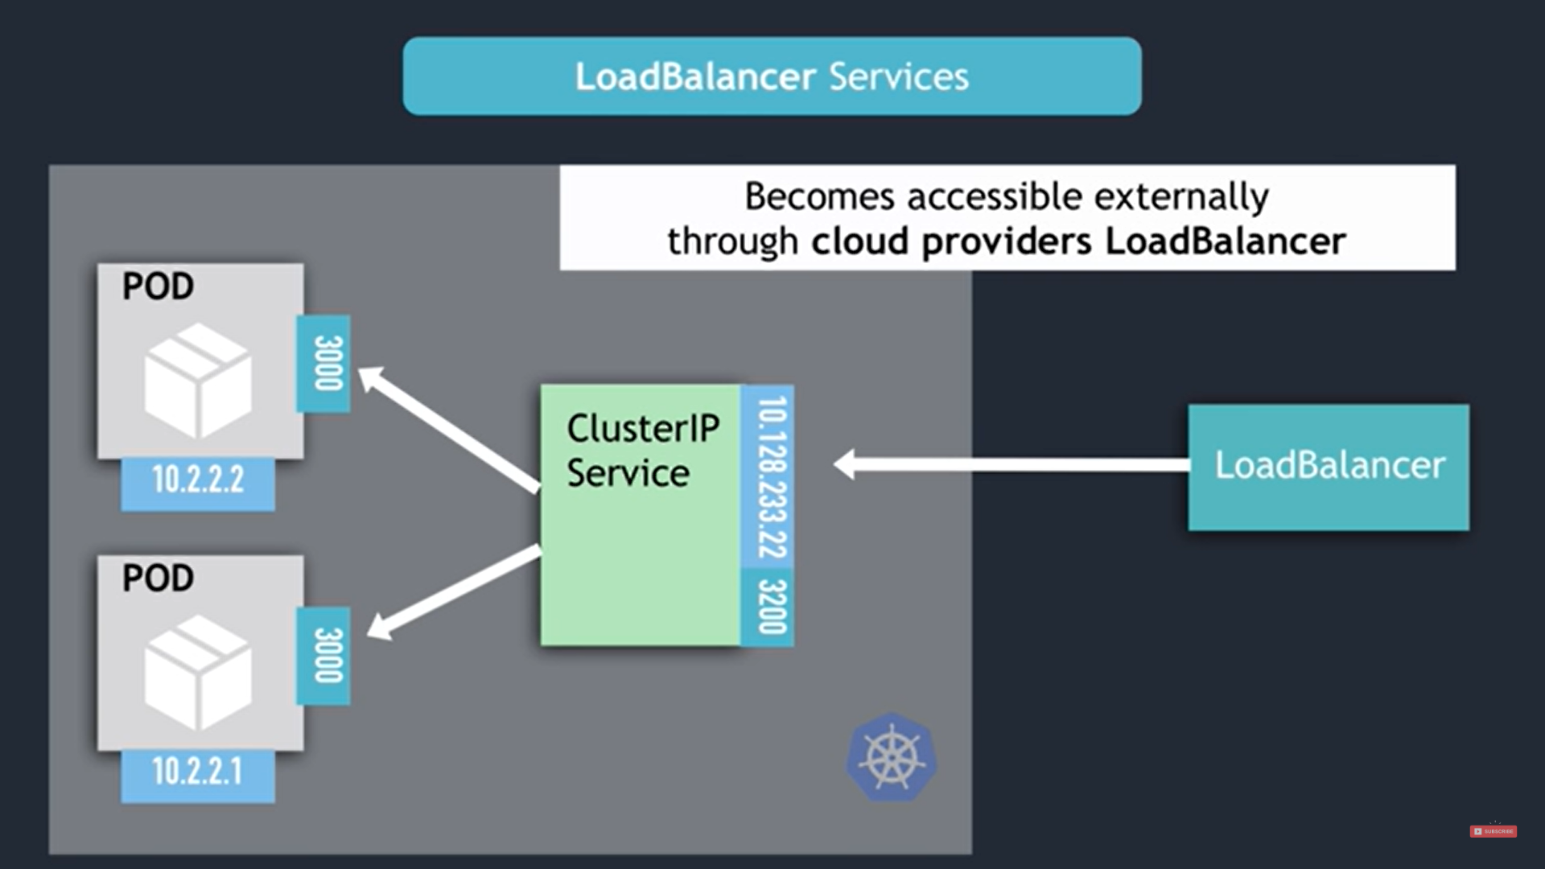
- Whenever load balancer service creates Node port and cluster IP service are created automatically.
